WEEK 1 SECURITY ASSESSMENT REPORT
User Management System Vulnerability Assessment
Prepared By: Muhammad Shahzaib DHC-3811
Date: March 2, 2026
Application: User Management System
URL: http://localhost:3000
Assessment Type: Manual Security Testing + OWASP ZAP Automated Scan

EXECUTIVE SUMMARY
This report documents the findings of a Week 1 security assessment conducted on a User Management System. The asse
ssment included manual vulnerability testing (SQL Injection, XSS, password storage review) and automated scanning using OWASP ZAP.
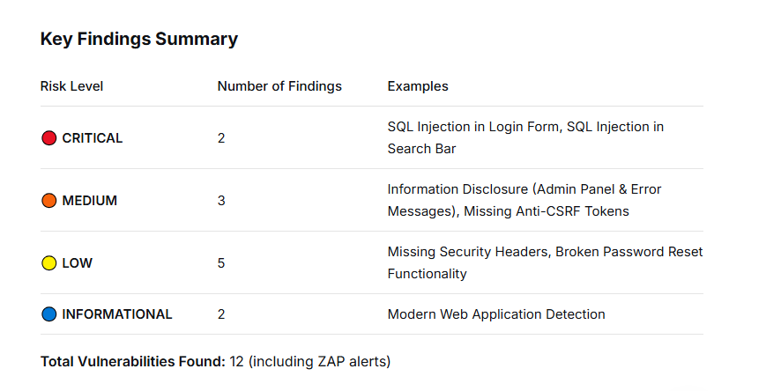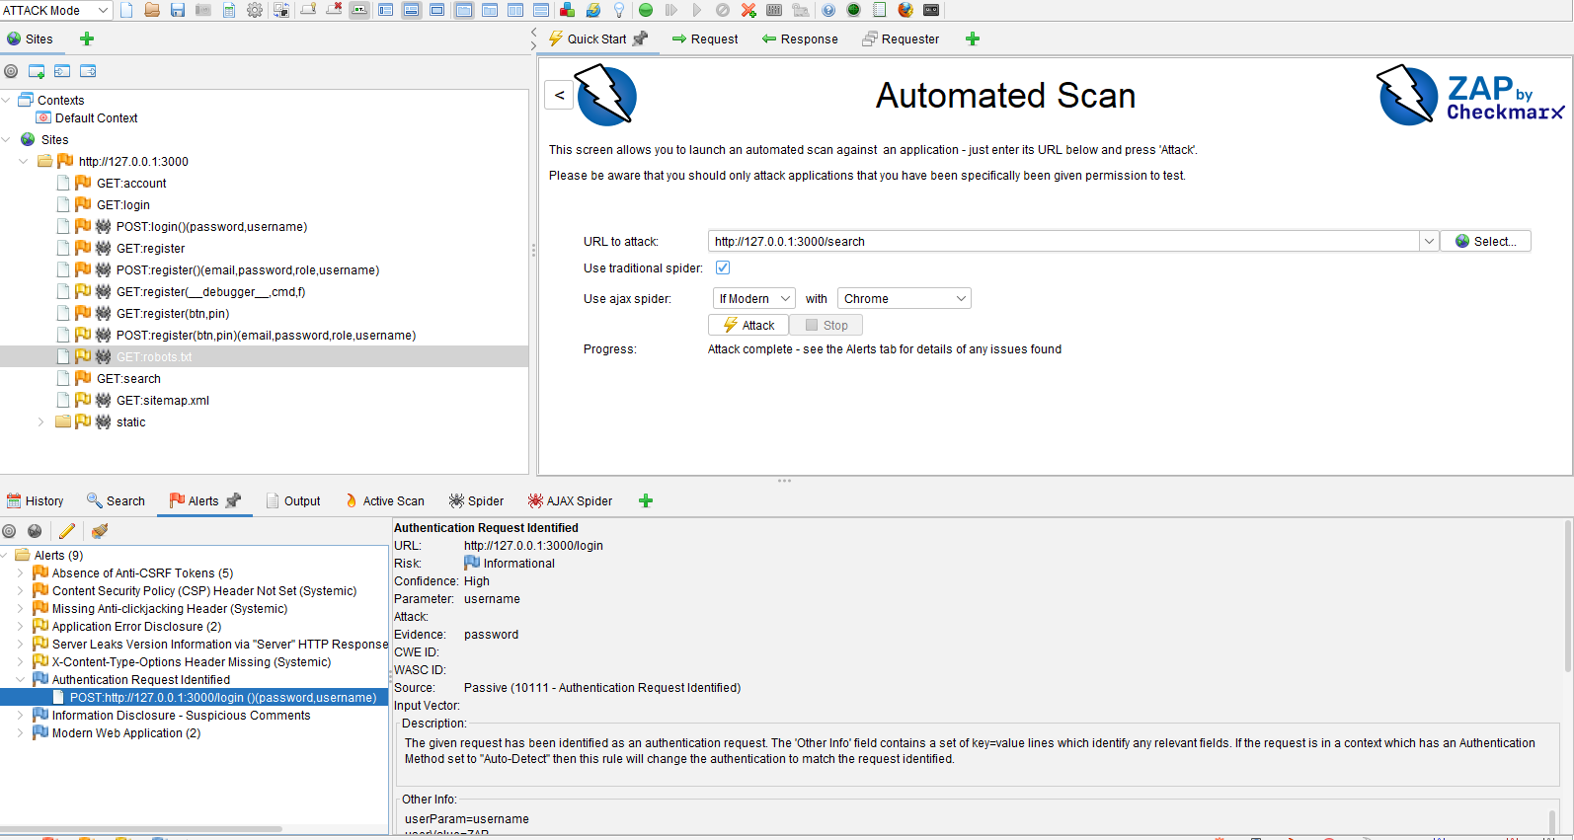
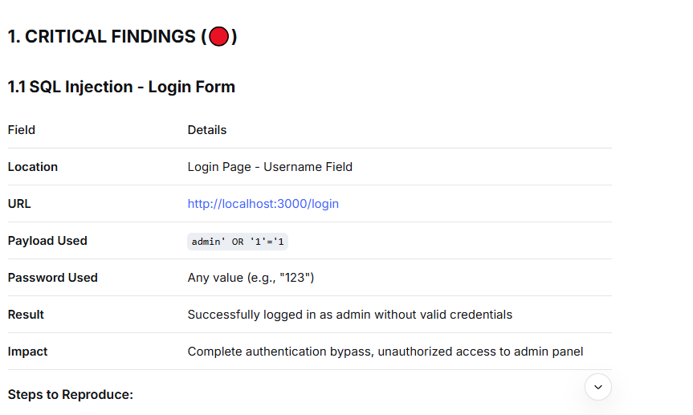
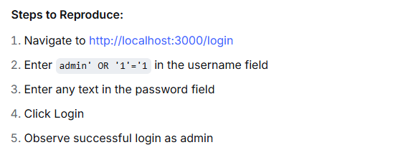
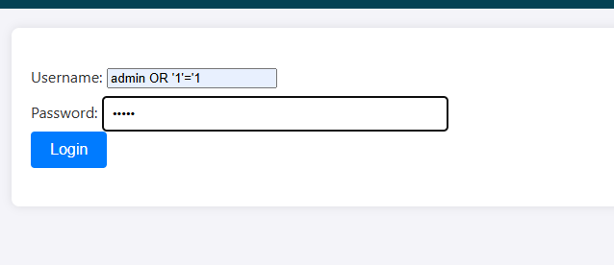

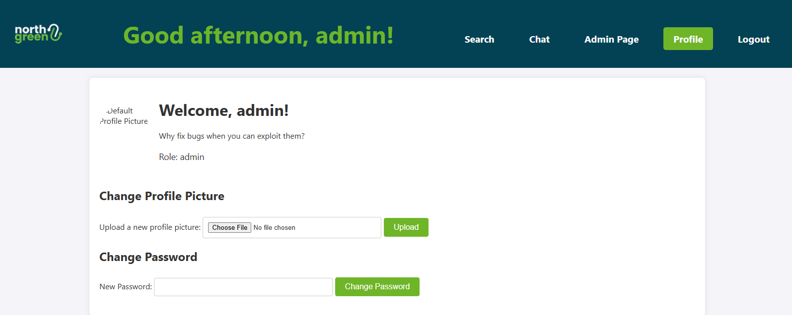

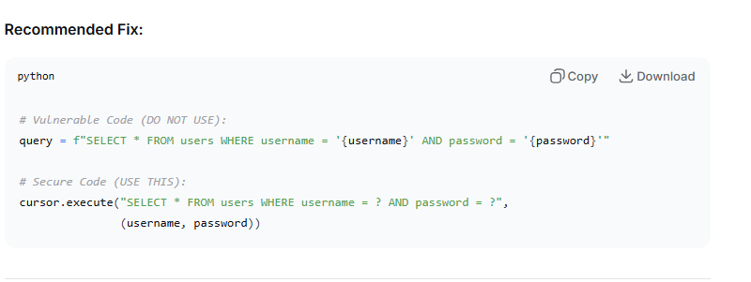
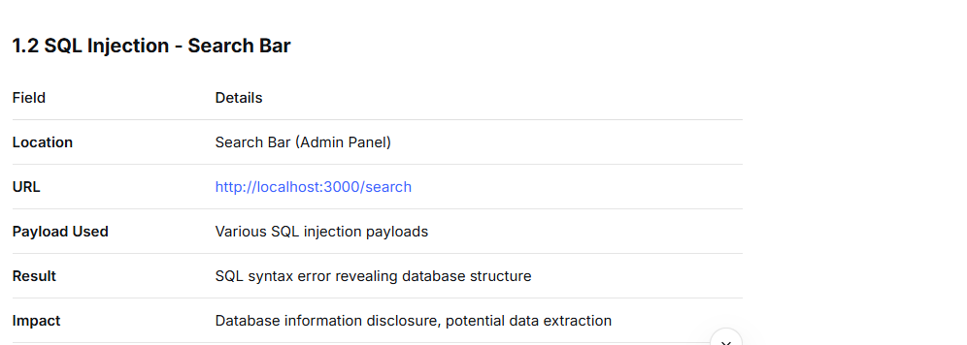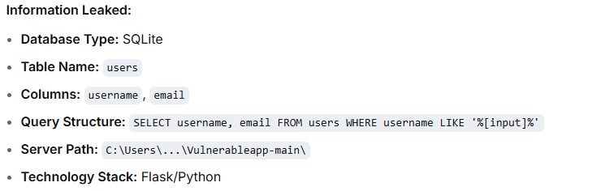
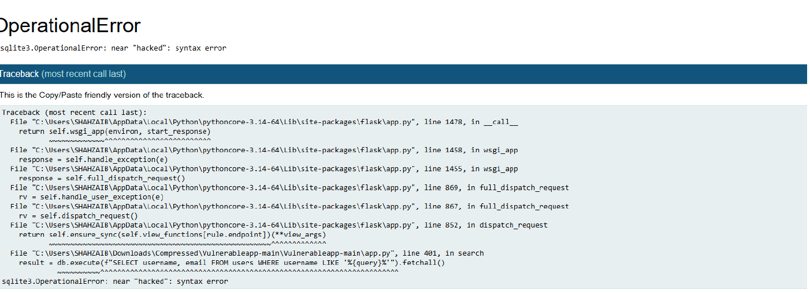
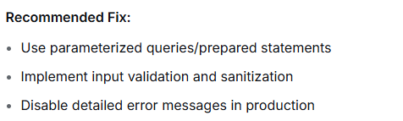

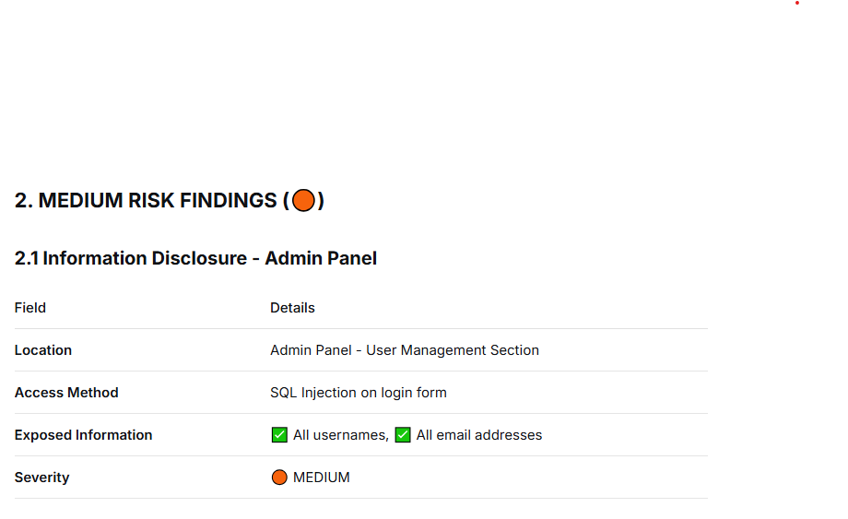

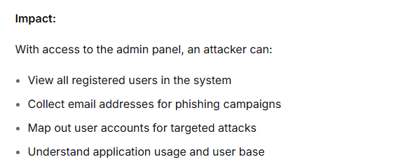

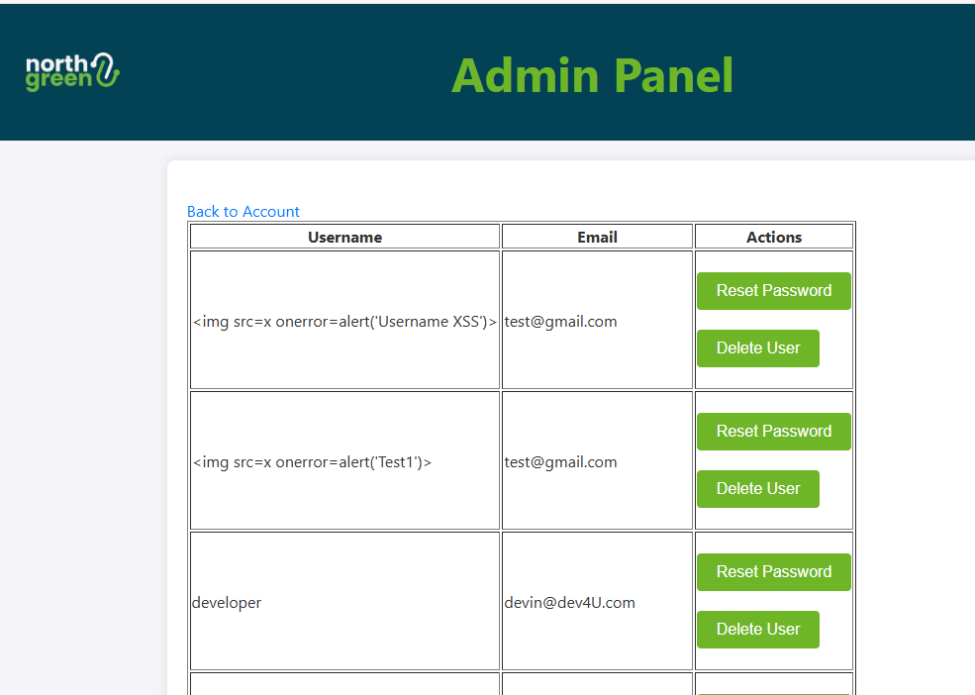
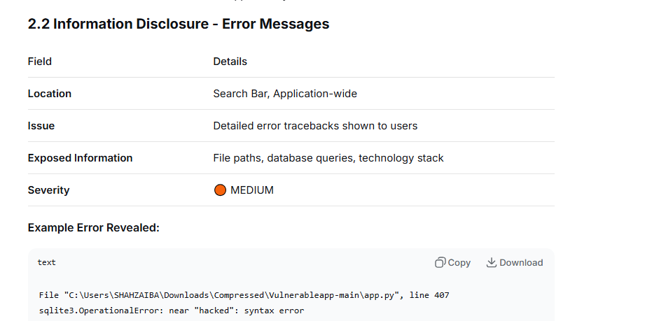

Recommended Fix:
- Disable debug mode in production
- Implement custom error pages
- Log errors internally, don't display to users
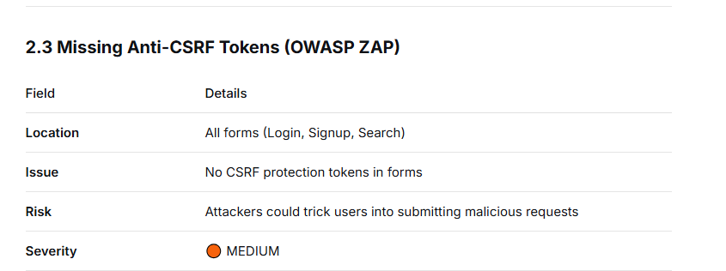
affected Forms:
- Login form
- Signup/Registration form
- Search form
- Any other forms in the application
Recommended Fix:
- Implement CSRF tokens in all state-changing forms
- Use framework-specific CSRF protection
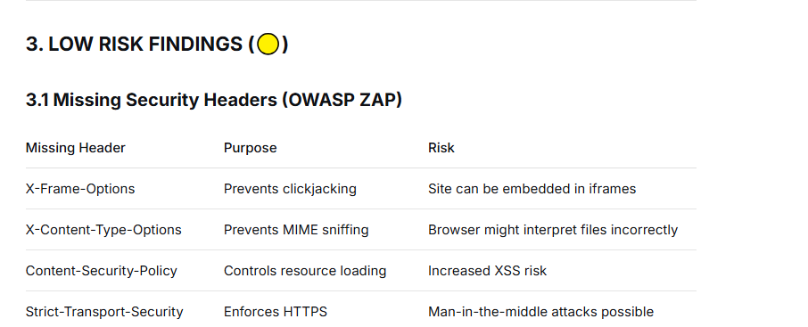

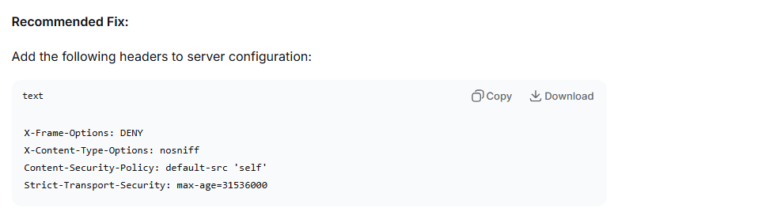
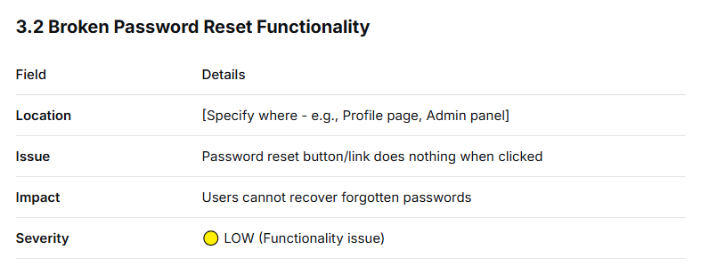

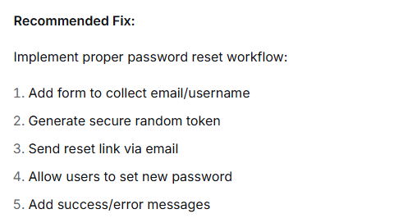

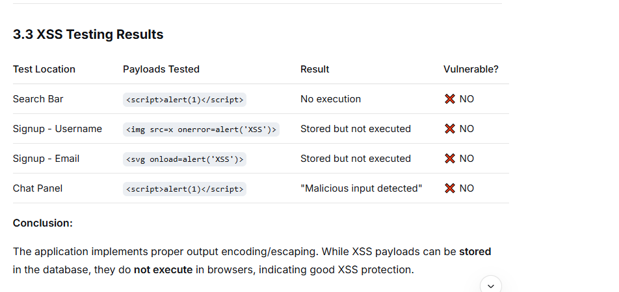

5. PASSWORD STORAGE ASSESSMENT
Testing Method
- Accessed admin panel via SQL injection
- Reviewed user list for password visibility
- Checked for password fields in database (if accessible)
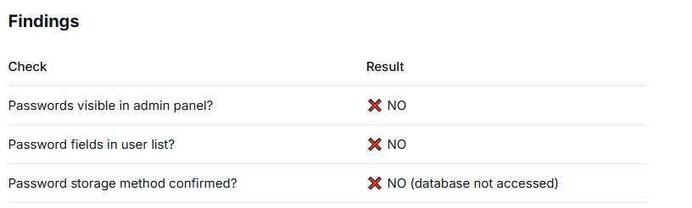
Conclusion
Passwords are not exposed in the admin panel interface. This suggests passwords may be hashed or stored separately. Without direct database access, the exact storage method cannot be confirmed.
Recommendation
Even if passwords are not exposed here, always:
- Use strong hashing algorithms (bcrypt, Argon2)
- Never store plaintext passwords
- Implement proper access controls
- Regularly audit password storage practices
FUNCTIONALITY ISSUES
6.1 Broken Password Reset
- Location: [Specify page]
- Issue: Button/link is non-functional
- Impact: Poor user experience, support burden
- Recommendation: Implement proper password reset workflow
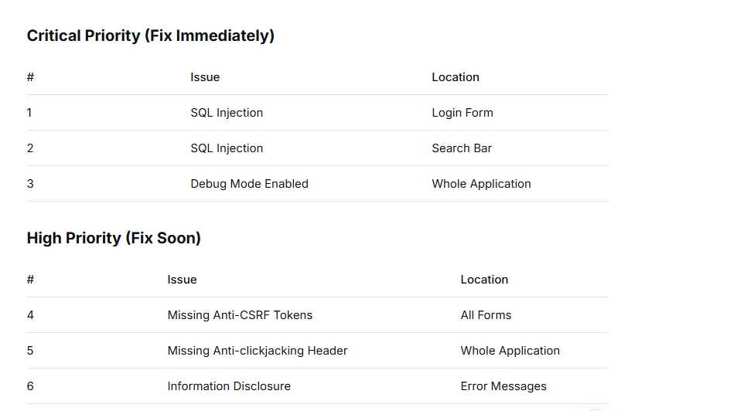
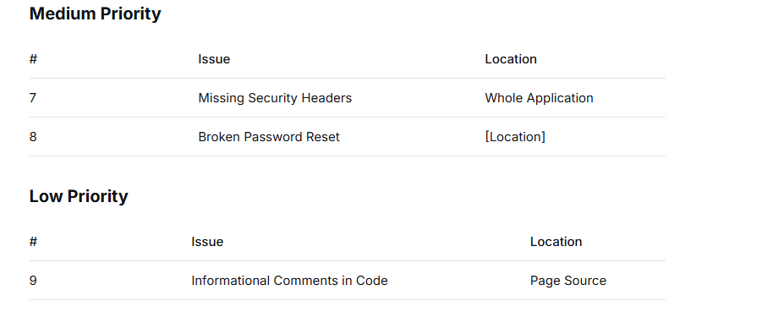CONCLUSION
This security assessment identified 12 security issues ranging from CRITICAL to LOW severity. The most critical findings include:
- SQL Injection vulnerabilities in both login and search functions
- Information disclosure via error messages and admin panel access
- Missing security headers and CSRF protection
- Broken functionality in password reset
Overall Risk Rating: 🔴 HIGH
The application requires immediate remediation of SQL injection vulnerabilities and proper security controls implementation. With the current security posture, the application is at high risk of data breach and unauthorized access.

